Johnson graph $J(7,3)$

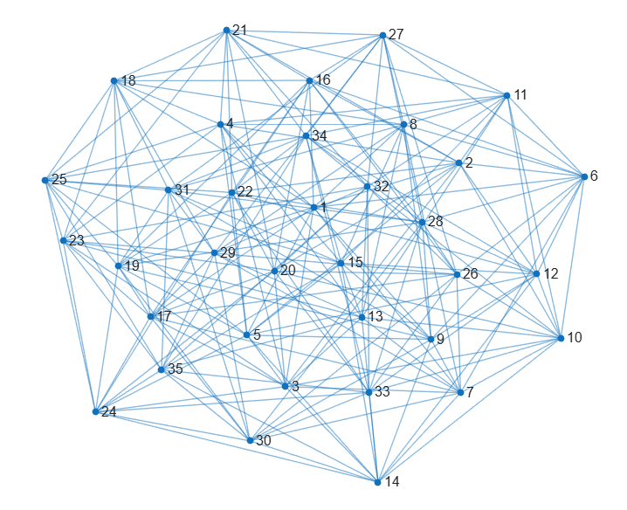

Metric dimension - 5

*BIGS Index* - 149184